MUSIC STORE DATA ANALYSIS USING SQL

Objective :

The goal of a music data analytics project using SQL is to gain insights and extract meaningful information from a set of music data. Using SQL queries and search techniques, the project aims to perform the following tasks

Q1: Who is the senior most employee based on job title?

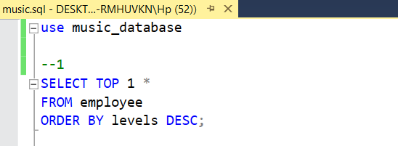

* This query retrieves the employee record with the highest level value.
* Insight: The top-level employee in the company can be identified for management or recognition purposes.

Q2: Which countries have the most Invoices?

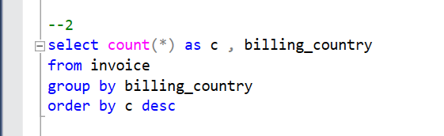

* This query calculates the count of invoices for each billing country and sorts them in descending order.
* Insight: The countries with the highest number of sales can be identified, helping to focus marketing efforts or understand customer preferences.

Q3: What are top 3 values of total invoice?

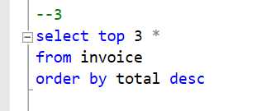

* This query retrieves the top three invoices based on the total amount, sorted in descending order.
* Insight: The highest revenue-generating invoices can be identified, which may provide insights into customer behavior or popular products/services.

Q4: Which city has the best customers? We would like to throw a promotional Music Festival in the city we made the most money. Write a query that returns one city that has the highest sum of invoice totals. Return both the city name & sum of all invoice totals

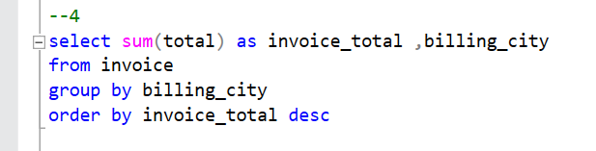

* This query calculates the sum of total amounts for each billing city and sorts them in descending order.
* Insight: The cities generating the highest revenue can be identified, allowing for targeted marketing or resource allocation.

Question 5: Who is the best customer? The customer who has spent the most money will be declared the best customer. Write a query that returns the person who has spent the most money.

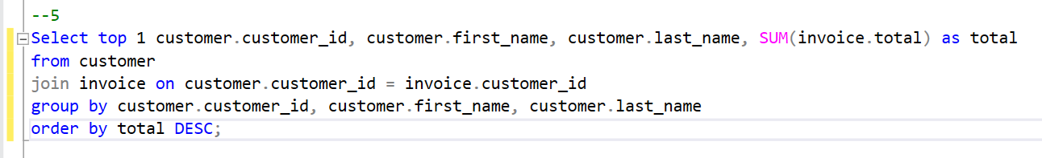

* This query calculates the total purchase amount for each customer, sorts them in descending order, and selects the top customer.
* Insight: The customer contributing the most to revenue can be identified for loyalty programs, targeted offers, or personalized marketing.

Question 6 : Write query to return the email, first name, last name, & Genre of all Rock Music listeners. Return your list ordered alphabetically by email starting with A

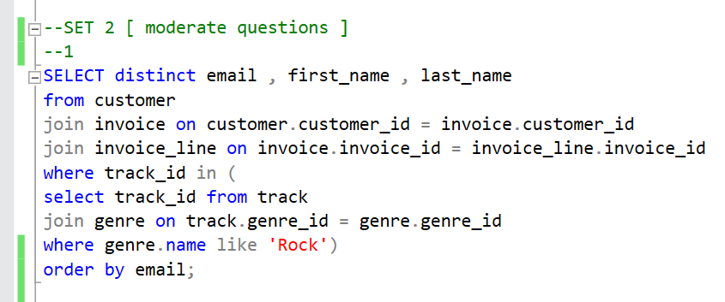

* This query retrieves distinct customer details who have purchased at least one rock music track and sorts them by email.
* Insight: Customers interested in rock music can be identified for targeted marketing campaigns or genre-specific promotions.

Question 7 Let's invite the artists who have written the most rock music in our dataset. Write a query that returns the Artist name and total track count of the top 10 rock bands

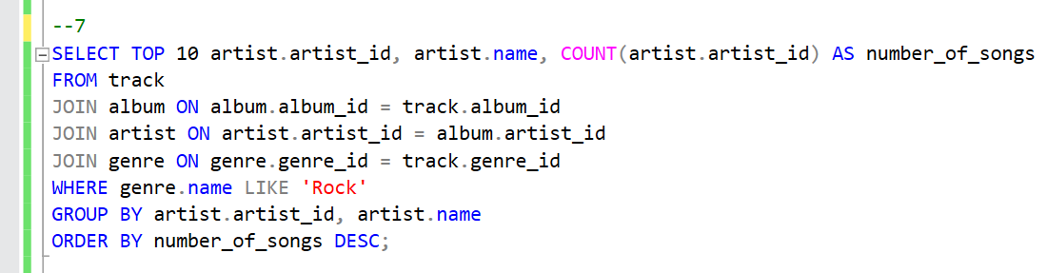

* This query counts the number of rock songs for each artist, selects the top 10 artists, and sorts them by the number of songs.
* Insight: The most prolific rock music artists can be identified, helping with artist promotions or genre-specific events.

Question 8 : Return all the track names that have a song length longer than the average song length. Return the Name and Milliseconds for each track. Order by the song length with the longest songs listed first.

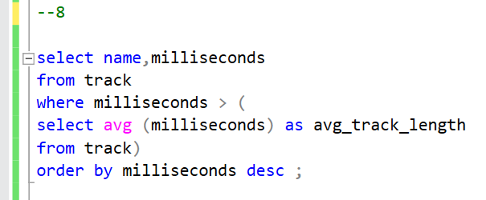

* This query retrieves track names and lengths where the track length is greater than the average track length, sorted in descending order.
* Insight: Longer tracks or tracks that deviate from the average length can be analyzed for customer preferences or genre-specific insights.

Question 9 : : Find how much amount spent by each customer on artists? Write a query to return customer name, artist name and total spent

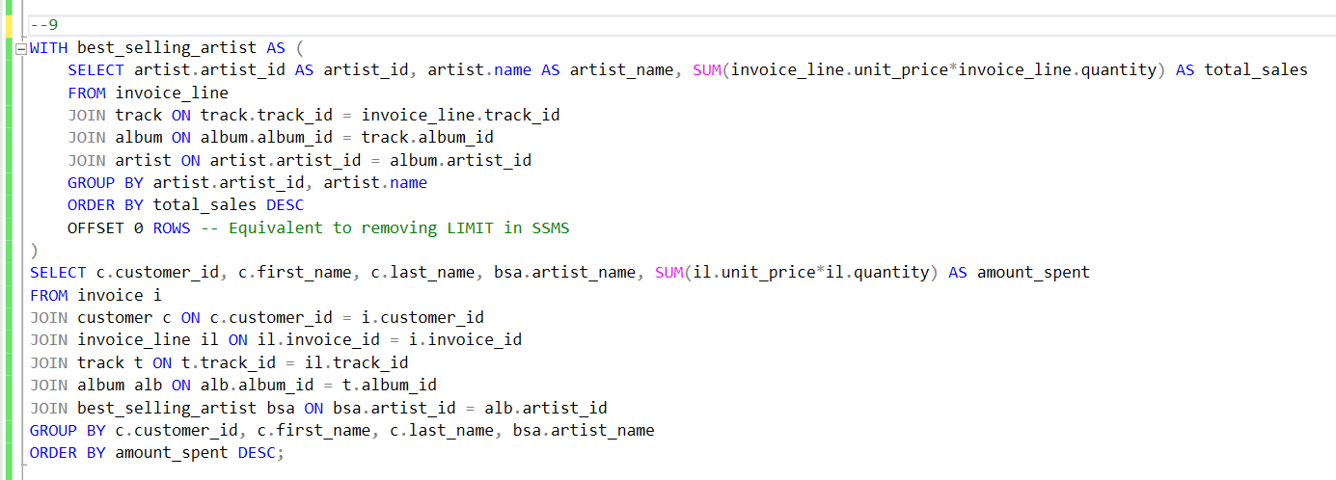

* This query calculates the total sales for each artist, selects the artist with the highest sales, and retrieves the customers who spent the most on that artist's tracks.
* Insight: The top-selling artist and customers who contributed the most to their sales can be identified, providing insights for artist collaborations, promotions, or partnerships.

Question 10 : : We want to find out the most popular music Genre for each country. We determine the most popular genre as the genre with the highest amount of purchases. Write a query that returns each country along with the top Genre. For countries where the maximum number of purchases is shared return all Genres.

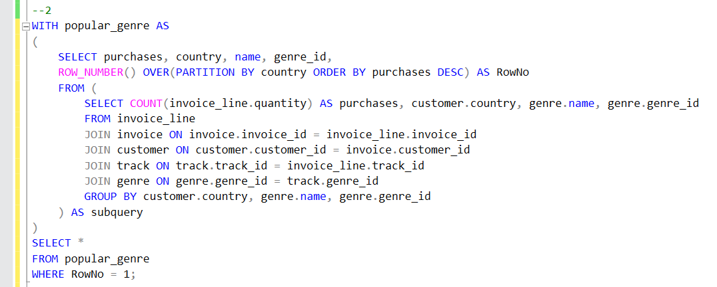

* This query counts the number of purchases for each genre in each country, selects the genre with the highest purchases for each country, and retrieves the result.
* Insight: The most popular genre in each country can be identified, allowing for targeted marketing or genre-specific promotions based on customer preferences.

Overview Of The Music Store Database Analysis :

The generated report highlights important aspects such as employee levels, sales by country, top invoices, invoice totals by city, highest-spending customers, rock music enthusiasts, top rock artists, track length analysis, best-selling artist and customers, and popular genres by country. Analyzing this information can help drive business decisions, marketing strategies, and customer-centric approaches for the music store.